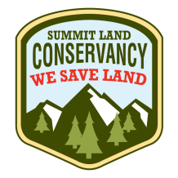
FOR IMMEDIATE RELEASE
Media Contact
Cheryl Fox
Executive Director
435-640-1171
cheryl@wesaveland.org

Family Makes Significant Contribution to Save Heritage and Farming Legacy
Osguthorpe Family makes additional $500,000 donation toward conservation easement purchase
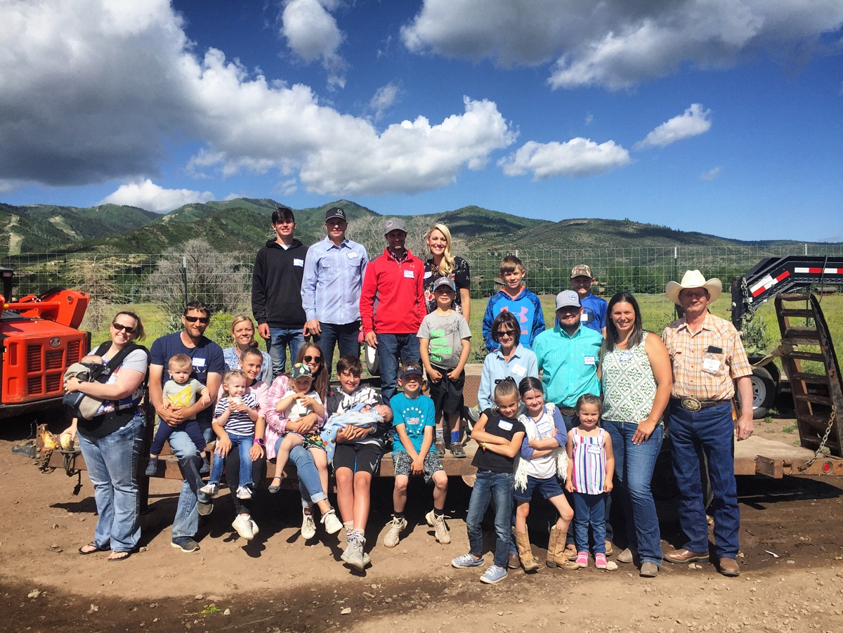
Three generations of the Osguthorpe family stand together on the farm during an event last June
(PARK CITY, Utah) February 27, 2019 – The Summit Land Conservancy, a nonprofit dedicated to saving land in Summit County, has approached the final stretch in their fundraising campaign to save the last farm on Old Ranch Road. Thanks to a new $500,000 contribution made by the Osguthorpe family, the land trust is now closer than ever to reaching their goal. Since September 2017, the Conservancy has been working to raise $5.6 million to preserve the 158-acre heritage amenity located in the heart of the Snyderville Basin.
In August 2017, the project received the largest grant ever awarded to farmland conservation in the state of Utah. The $8.8 million federal grant from the NRCS (Natural Resources Conservation Service) Agricultural Conservation Easement Program comes from a Farm Bill program established to protect the long-term viability of productive working lands like the Osguthorpe Farm. Summit Land Conservancy has leveraged the federal funds with grants, including a $500,000 contribution made by Summit County this past November, and private donations. More than 900 donations have been made amounting to over $3.5 million.
The Osguthorpes have recognized the community’s tremendous efforts to protect their land, and have agreed to further reduce the purchase price of the farm ($17,775,000) by $500,000 totaling a landowner gift of $3.9 million. They remain open to the possibility of wintertime recreational access for the public as long as it can coexist with their agricultural use, much like their 121-acre ranch in Round Valley, home to the ‘Land of Oz’.
“The family is very appreciative of Summit Land Conservancy and all the work they’ve done. We’re excited to get close to wrapping it up,” said local rancher and landowner Steve Osguthorpe. “It would break my heart to see houses on this farm.”
The property on Old Ranch Road has been owned and operated by the Osguthorpe family since the 1940’s and is one of the last agricultural open spaces in the Snyderville Basin. The Osguthorpes have a history of working with local governments to save open spaces like the ‘McPolin Barn’ and Farmlands, PC Hill, the North 40 soccer fields and the ‘Land of Oz’ in Round Valley. In 2011, Steve Osguthorpe won the Sand County Foundation’s ‘Leopold Conservation Award’ which recognizes agricultural landowners who demonstrate a deep commitment to land conservation.
“We’ve never developed any property here. We have preserved it for the benefit of our community,” stated Osguthorpe.
The Summit Land Conservancy has $800,000 left to raise before the end of March. They hope to close on the easement in April.
“This has been a long road and we are almost to the finish,” said Cheryl Fox, Executive Director of the Summit Land Conservancy. “We hope that people will recognize the incredible generosity of this family and their fundamental commitment to conservation. They are saving their land and our agricultural heritage, leaving a legacy for our entire community.”
SUMMIT LAND CONSERVANCY HERITAGE RANCH PROJECTS:
2019 Stephens Ranch 44 acres Henefer
2019 Anonymous 82 acres Wanship
2017 Ercanbrack Ranch 2,161 acres Coalville
2015 Siddoway Ranch & Wetlands 73 acres Peoa
2013 Dog Holler Organic Farm 85 acres Hoytsville
2013 Pyper Tracey Ranch 50 acres Henefer
2012 Osguthorpe Ranch Round Valley 121 acres Park City
2011 Judd Ranch 35 acres Wanship
2009 Fawcett Ranch 44 acres Henefer
2005 McPolin Farmlands 116 acres Park City
2005 Richards Ranch 19 acres Park City

###

About Summit Land Conservancy
Born in Park City in 1998 as a project of Leadership Park City, the Summit Land Conservancy works with Summit County’s communities to protect and preserve land and water for the benefit of people and nature.
In 2011, the Conservancy became the first land trust in the state of Utah to be nationally accredited by the Land Trust Accreditation Commission. It currently holds 38 permanent conservation easements on over 5,700 acres of open space, much of it with public access in and around Park City. It protects swathes of Round Valley, Quarry Mountain, Empire Canyon, and the McPolin Farmlands, as well as farms and ranches along the Weber River. It is currently working to preserve an additional 5,000+ acres of land including the Osguthorpe Farm located on Old Ranch Road.
The Conservancy’s goal when it started in 1998 was to raise money locally to save land locally, and that hasn’t changed. But it has expanded its efforts throughout the years to tap additional funding resources. Since 2011, the Conservancy has brought in over $6 million federal dollars for land conservation in Summit County.
As a local land trust based in Park City, the Conservancy understands that open space is the heart of the County’s communities. Area residents’ sense of place is clearly defined by the shared landscapes that anchor them here. The mountains, trails, farms, and rivers connect people to each other and to the natural world. The Summit Land Conservancy cares for these lands forever, nurturing a healthy community that is founded on its strong connection to the places it has protected together.
More information is available on the Conservancy’s website (wesaveland.org) and on Facebook (facebook.com/WeSaveLand), Instagram (instagram.com/wesaveland) and Twitter @Summit_Land (twitter.com/summit_land).

